**FINAL RESULTS : FACTORS OF IMPORTANCE**

All the graphs shown below are in response to ***‘result’***: True - adoption; False - no adoption

***creation_time (year)***:

* More users have signed up in the year 2013 than for the other years. 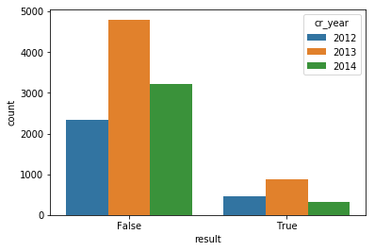
* Based on the number of adopted users from the pool of new sign-ups for each year, the adoption rate for 2012 is 16%, followed by 15% for 2013 and just 8% for 2014.
* The practices followed in the year 2014 needs to be revised.
* More number of users have signed up during May, March and April.
* March (sign-up) has the most adoption rate.

***creation_source***:

* Org_invite is the most important factor for signing up users 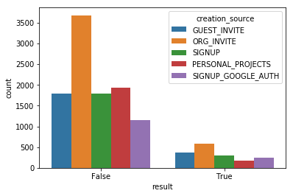
* Signup_google_auth is the most effective way to retain users (17.2% adoption rate followed by 17% from guest_invite and then 14.5% through sign-ups and 13.5% through org_invites)
* Personal projects method of signing up are the least effective

***no. of visits***: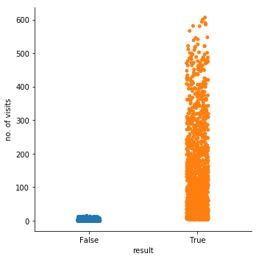

* No. of visits is a variable I introduced from the user engagement file.
* This factor is highly predictive of adoption
* More the number of visits, more is the chance of adoption

***opted_in_to_mailing_list/ enabled_for_marketing_drip***: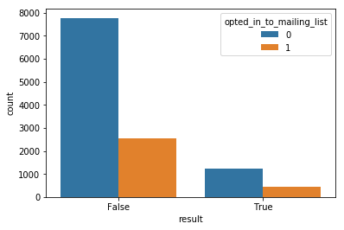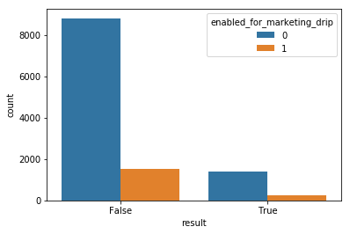

* 14.3% of the users who sign up for any of these 2 methods turn into adopted users when both methods are considered independently. (both are equally not *that* effective)

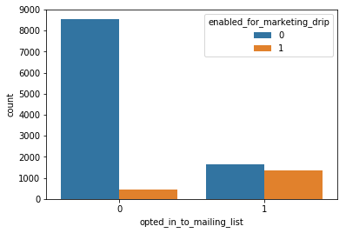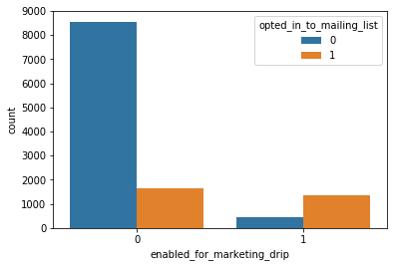

* Almost 50% of users who opt in for mailing list are also enabled for marketing drips.
* Users enabled for marketing drips are likely to opt in for mailing lists

